***Train Simulator***



***Use Case Summary Document***

**Version No. 2.0**

|  |
| --- |
| **Table of Contents** |

**1. Introduction 3**

**2. Project/Application Actors 3**

[**3. Use**](https://docs.google.com/document/d/1NGb8Co7VDW29XF97g3q9cObDBz3tHtQe5-wemsA_t34/edit#heading=h.tyjcwt) **Case List 4**

**4. Use Case Diagram(s) 5**

**5. Use Case Summary 6**

**6. Use Case Summary Review and Signoff 9**

# **1. Introduction**

The purpose of the project is to develop a railroad simulation that will act out several weeks of operation and allow the user to evaluate the performance of the system. The railroad’s infrastructure may be edited, and the user will be given tools and a train priority system to help enhance the functionality of the entire system. Stations, hubs, railways, and trains may be added or deleted in order to maximize the efficiency of daily use. All information will be collected, stored, and visually displayed to the user.

The system will allow the user to carry out various commands through the interface that will directly affect the simulation. The program will output important statistics to the user once finished running with the selected parameters, along with comparison if requested. The analytics may consist of things like edge usage, individual or total train downtime, station or hub usage, and fuel consumption and utilization in order to compare changes made between simulations. The program will also be able to create external, formatted, files with raw data that can be used for easy modeling in other programs.

In addition to the simulation’s standard functionalities provided, the user will also be able to incorporate additional functionalities to better simulate real world conditions. After each simulation, the program will give an automated report highlighting problem areas and give suggestions on fixes, along with a report on the cost of running the trains through distance and weight calculations. Through the interface, the user will able to implement a random weather system and choose its severity to further try and simulate real life conditions.

# **2. Project/Application Actors**

|  |  |
| --- | --- |
| Actor Name | Description |
| Simulation System | Runs simulation using data about railroad and schedules from files. ~~Display activity.~~ |
| UI System | Show visual representation of simulation graph. |
| User | This is a human that starts and stops simulation. Select files that would be read and processed. Start simulation to create new day. Weather is decided by user. View files. Add hubs, stations, and tracks. Adjust hubs and stations associated with tracks. |
| File Generator | This is a system that will create ~~and~~ and edit files during and of end simulation. |
| Weather System | This is a system that modifies the weather within the simulation. |
| Suggestion System | This is a system that will trigger after the simulation ends and will send a file of suggested options. |
| Maintenance System | This is a system that will control maintenance that is occurring on a given day. System will recognize tracks and trains that are under maintenance prior to start of day. |

# **3. Use Case List**

1. Setup Initial State
2. Add/Remove Trains
3. Edit Railway
4. Adjust Weather
5. Update Graph
6. Run Simulation
7. Track Statistics
8. Recommended Changes
9. View Statistics
10. Rollback Simulation History

**4. Use Case Diagram(s)**

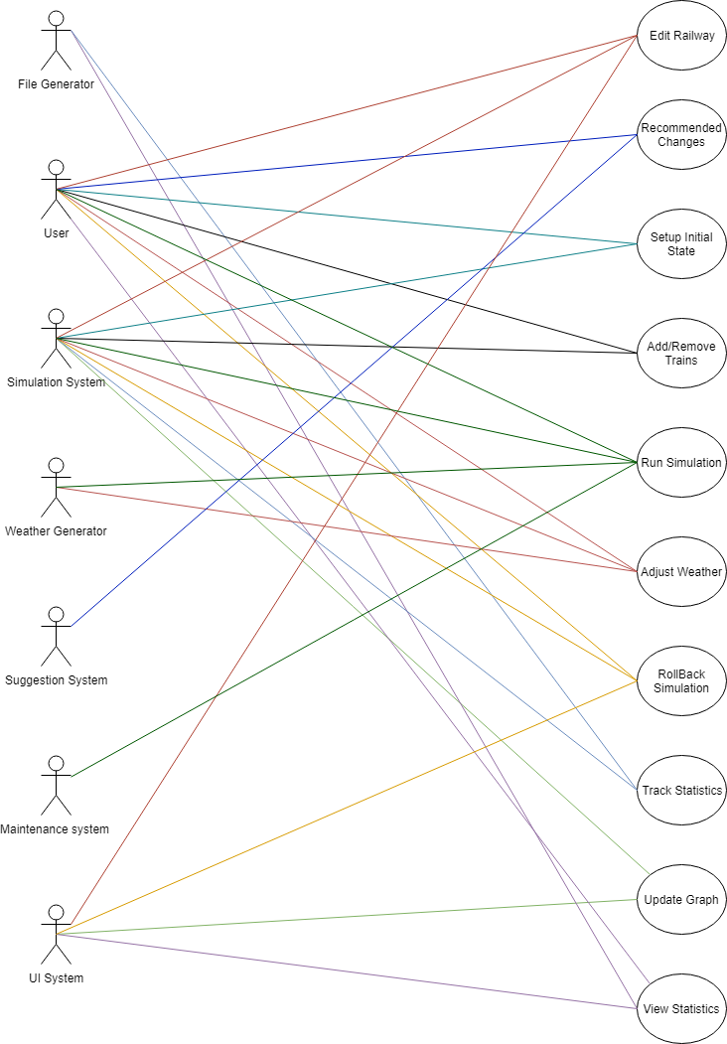

# **5. Use Case Summary**

1.) Setup the initial state ~~or update railroad~~ (Zaid)  
 a) Introduction: User will be able to enter files of information for the simulation system to have an initial state for the simulation to run. Once all initial files are read the simulation will accept or decline any files that are not in the right formation or with the correct data. When all files are accepted the simulation will have an initial state for it to be able to run the simulation.  
 b) Main actors: User, Simulation System  
 c) Secondary actors: N/A

2.) Add/remove trains ~~from the simulation~~ (Brendan)  
 a) Introduction: User will be able to add or remove trains from the railroad simulation. This will be done before each simulation is run. In the creation of new locomotives, train type, starting hub, and capacity must be chosen by the user.   
 b) Main actors: User  
 c) Secondary actors: Simulation System

3.) Edit Railway (Brendan)  
 a) Introduction: This case and the associated tools will allow the user to modify the railway layout. This includes the ability to create and delete track connections, stations, and hubs. This may be done before each simulation aside from the first. The weight of new track pieces will be determined by the two endpoints’ positions. A station/hub may not have its final track connection removed without another being placed. The user may not delete the last station or last hub.  
 b) Main actors: User  
 c) Secondary actors: Simulation System, UI System

4.) Adjust weather options (Abbass)

Introduction:To simulate real world conditions, the option to modify the weather is given to the user. The severity of the weather will directly correlate to the frequency of delays in the simulation on a given day. Some days will have greater delays than others due to varying weather conditions. A user may choose to enable this option and set severity prior to running the simulation.

Main Actors: User, Weather System

Secondary Actors: Simulation System

5.) Update Graph (Maxx)

Introduction: Update graph allows the Simulation System (name pending) to change what currently exists in our graph after initial setup. Once the first simulation is ran, user would have the option to do the following such as add tracks, hubs, and stations. Once all options are completed, the graph would then be updated and ready for the next simulation run.~~\~~

Main Actors: Simulation System, UI System

Secondary Actors: N/A

6.) Run Simulation (Alex)

Introduction: The user will be given two opportunities to run their simulation: after they have imported their initial data from files to set up the initial graph and after they have made any changes to the simulation. The simulation will run according to the parameters set by the user and the simulation systems graph creation. It will be affected by the weather severity and addition or removal of trains, tracks, stations, and hubs. The data will then be stored and made available to the user after each run of the simulation.

Main Actors: User, Simulation System, Weather System, Maintenance System

7.) Track ~~Simulation~~  Statistics(Maxx)

Introduction: Tracking Statistics is what would be used in order for data could be created. This would include the amount of time a train is used, the amount of travel done throughout the day, total costs, etc. With this information, it would allow the user to analyze the data in a visual perspective. Through this idea, updates can then be created in a logical way that would benefit companies that wish to use our system with positive results.

Main Actors: File Generator

Secondary Actors: Simulation System

8.) Recommended Changes (Alex)

* 1. Introduction: After the user runs a simulation, the program will generate a file that will give the user potential changes that can be made to improve the efficiency of the railway. The system will analyze data from each simulation run and suggest changes that can be made using the UI, such as:
     1. Adding new tracks when high edge traffic is found
     2. Adding new trains when there is a high arrival/departure delay time
     3. Adding stations if new routes may be required
     4. Adding hub if space is needed for new trains, or for easier fueling
     5. Choosing secondary route if the route encounters high traffic
  2. Main Actors: Suggestion System
  3. Secondary Actors: User

9.) View statistics (Orlando)

Introduction: After the simulation has been executed, the user will be able to view various metrics gathered involving stations, trains, hubs, and railways. Metrics include: average railway usage, average train station usage, total train downtime, total train delay, etc.

Main Actors: User

Secondary Actors: Simulation system, UI System, File Generator

10.) Rollback Simulation History (Orlando)

Introduction: Users will be able to compare metrics and data from their current simulation with previous data points. A side-by-side comparison will be available to view metrics about trains, train stations, hubs, railways, and trains after providing a date in between the start and end dates for comparison. The previous data will be available without re-running the entire simulation.

Main Actors: User

Secondary Actors: Simulation System, UI System

# **6. Use Case Summary Review and Signoff**

|  |  |  |  |
| --- | --- | --- | --- |
| Review and Signoff of the Use Case Summary | | | |
| LAST NAME | FIRST NAME | SIGNATURE | DATE |
| Achtman | Maxx |  |  |
| Alsafi | Zaid |  |  |
| Batchelor | Brendan |  |  |
| Moradiya | Radhika |  |  |
| Murrell | Orlando |  |  |
| Navarre | Alex |  |  |
| Srour | Abbass |  |  |